[Expt 9 Support Vector Regression](https://lms.snuchennai.edu.in/course/view.php?id=565" \l "section-9)

* Choose a prediction dataset from any challenge website.
* Apply support vector regression.
* Use different kernels and finetune hyperparameters.
* compare the max performance (least prediction error) by [SVR](https://lms.snuchennai.edu.in/mod/assign/view.php?id=12913) with that of the linear regression.
* Write your comments.

import pandas as pd

import numpy as np

import matplotlib.pyplot as plt

from sklearn.model_selection import train_test_split

from sklearn.preprocessing import StandardScaler

from sklearn.svm import SVR

from sklearn.metrics import mean_squared_error

# Load the dataset

data = pd.read_csv("/content/HeightVsWeight.csv")

# Splitting data into features and target variable

X = data['Height'].values.reshape(-1,1)  # Reshape for single feature

y = data['Age'].values

# Splitting the data into training and testing sets

X_train, X_test, y_train, y_test = train_test_split(X, y, test_size=0.2, random_state=42)

# Feature scaling

scaler = StandardScaler()

X_train_scaled = scaler.fit_transform(X_train)

X_test_scaled = scaler.transform(X_test)

# SVR with linear kernel

svr_linear = SVR(kernel='linear')

svr_linear.fit(X_train_scaled, y_train)

y_pred_linear = svr_linear.predict(X_test_scaled)

mse_linear = mean_squared_error(y_test, y_pred_linear)

# SVR with polynomial kernel

svr_poly = SVR(kernel='poly', degree=3)  # Degree 3 polynomial kernel

svr_poly.fit(X_train_scaled, y_train)

y_pred_poly = svr_poly.predict(X_test_scaled)

mse_poly = mean_squared_error(y_test, y_pred_poly)

# Plotting results

plt.figure(figsize=(10, 6))

plt.scatter(X_test, y_test, color='black', label='Actual')

plt.plot(X_test, y_pred_linear, color='blue', label=f'Linear SVR (MSE={mse_linear:.2f})')

plt.plot(X_test, y_pred_poly, color='red', label=f'Polynomial SVR (MSE={mse_poly:.2f})')

plt.title('Support Vector Regression (SVR)')

plt.xlabel('Height')

plt.ylabel('Weight')

plt.legend()

plt.show()

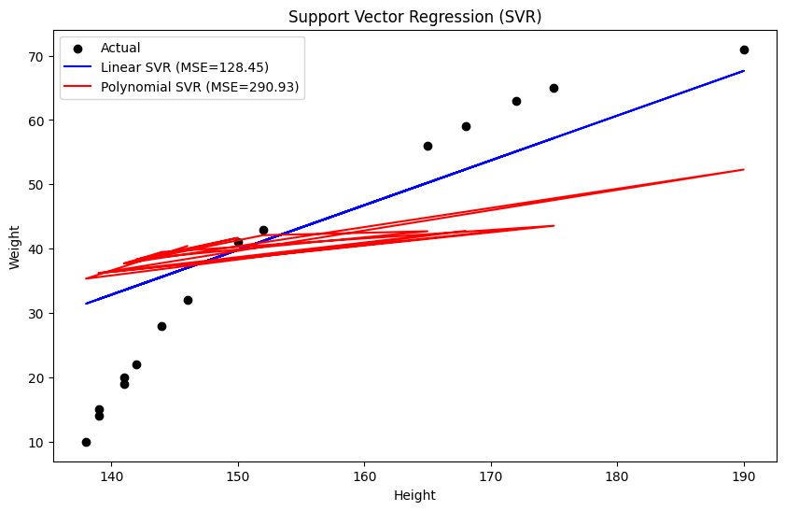

print("SVR with Linear Kernel - Mean Squared Error:", mse_linear)

print("SVR with Polynomial Kernel - Mean Squared Error:", mse_poly)

SVR with Linear Kernel - Mean Squared Error: 128.44767315853835

SVR with Polynomial Kernel - Mean Squared Error: 290.92788615130786